This project demonstrates the deployment of a React-based Trend application using Docker, DockerHub, Terraform, Jenkins, Kubernetes and Amazon EKS. GitHub is used for version control, Jenkins is used for CI/CD automation, Docker is used for containerization, DockerHub is used as the container registry, and Amazon EKS is used for Kubernetes-based application deployment. Prometheus and Grafana are used for monitoring the Kubernetes environment and application health.

GitHub Repository:
https://github.com/NaveenOVN/Trend
Load balancer ARN: http://a2df0d047ca974ed598b7af119b33a4e-154068039.ap-south-1.elb.amazonaws.com:3000

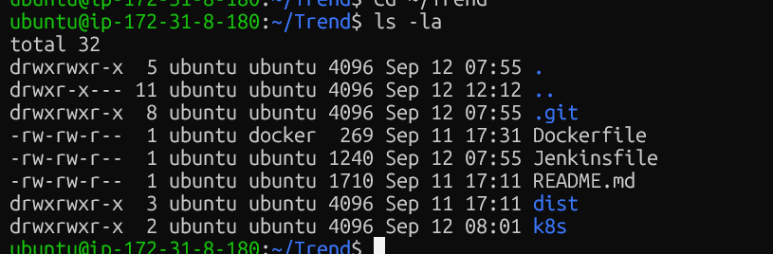

GitHub Project Files
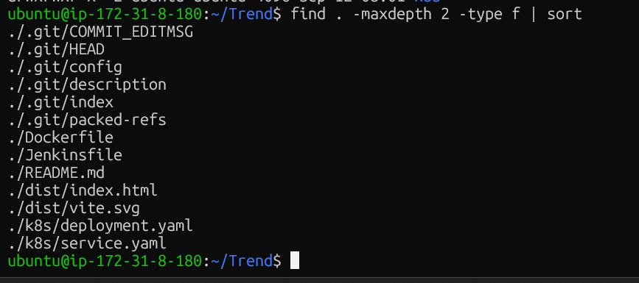

Docker Configuration
Docker images are pushed to DockerHub after successful Docker image creation. Jenkins automatically builds and pushes the image during the CI/CD pipeline.
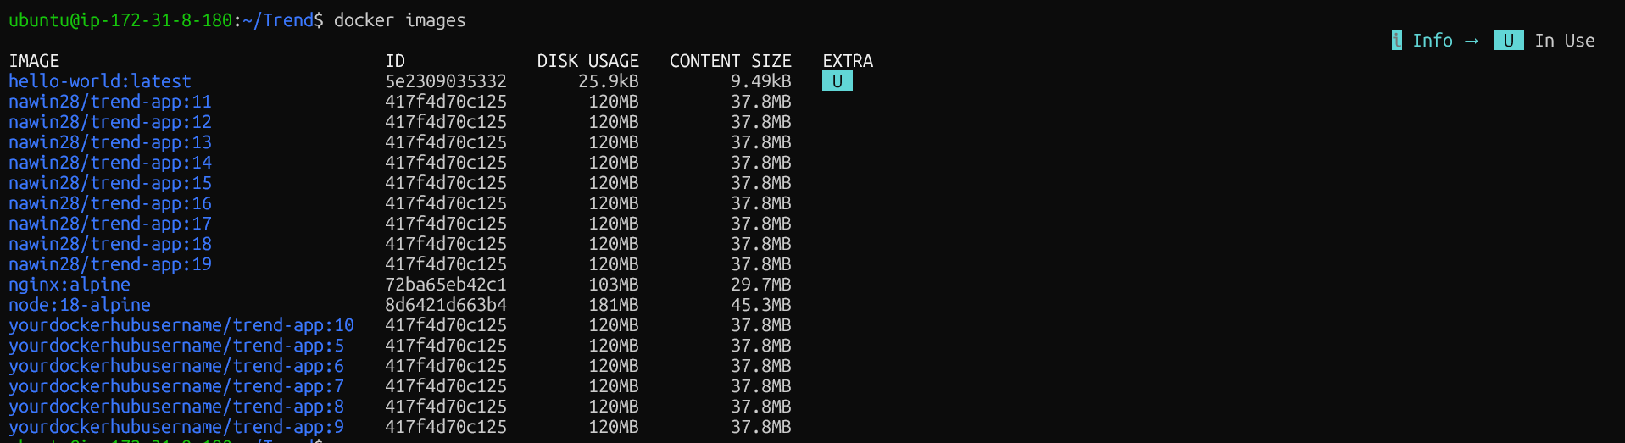
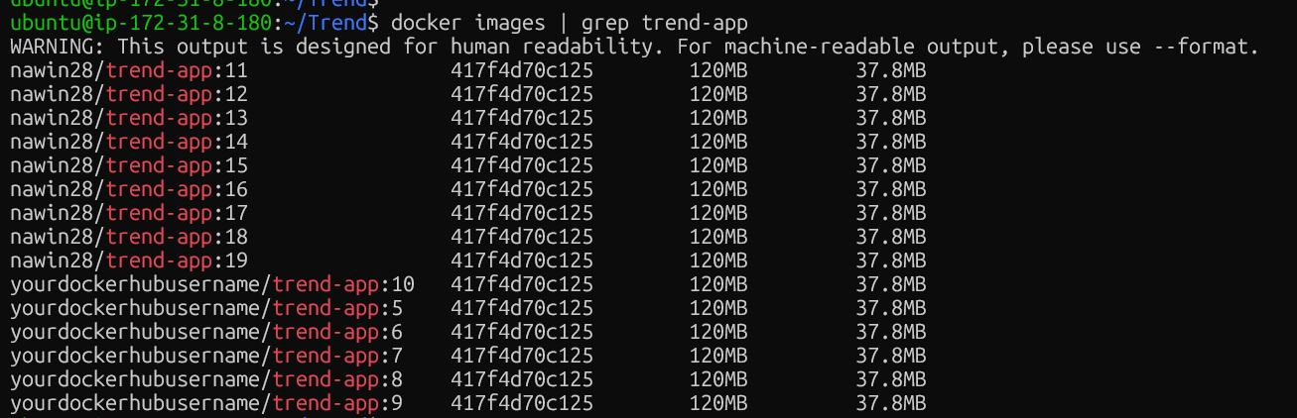
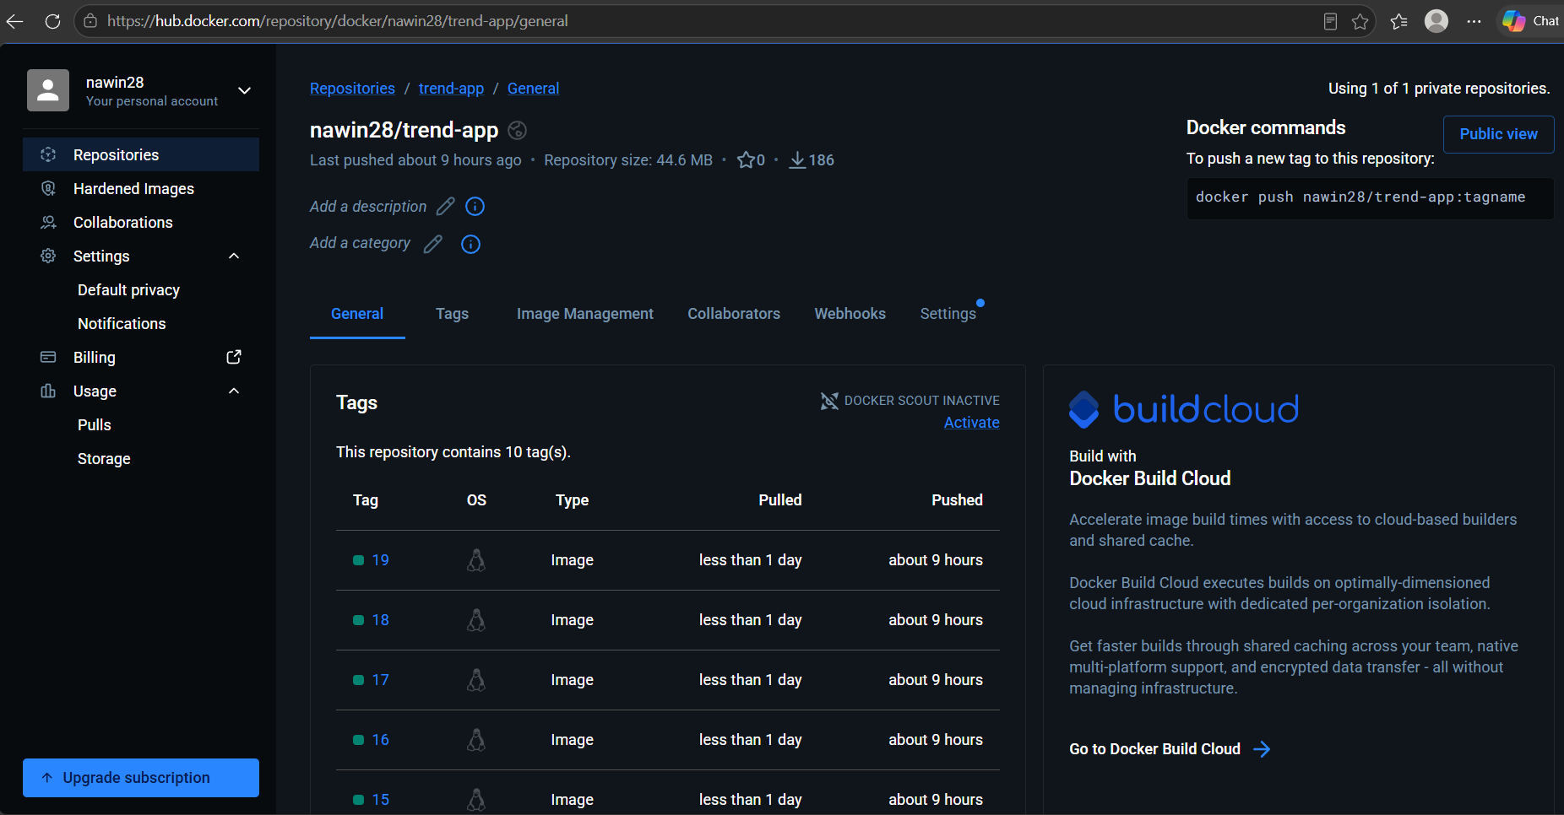

Terraform Infrastructure
Terraform was initialized and the infrastructure configuration was validated successfully.
Terraform int
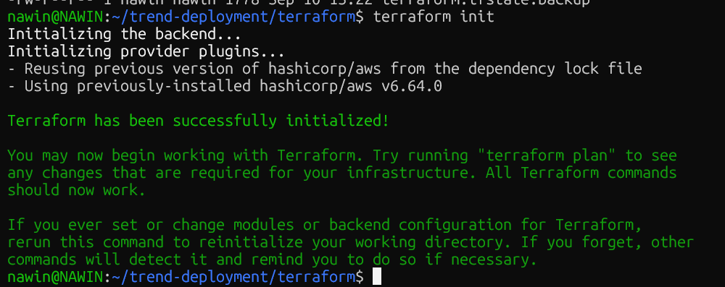

Terraform validate
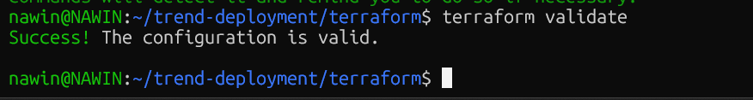

Terraform Plan
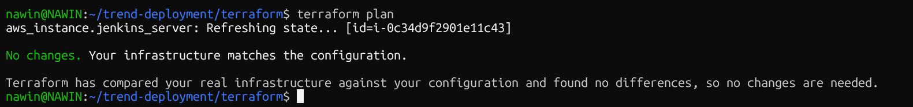

Amazon EKS Cluster Verification
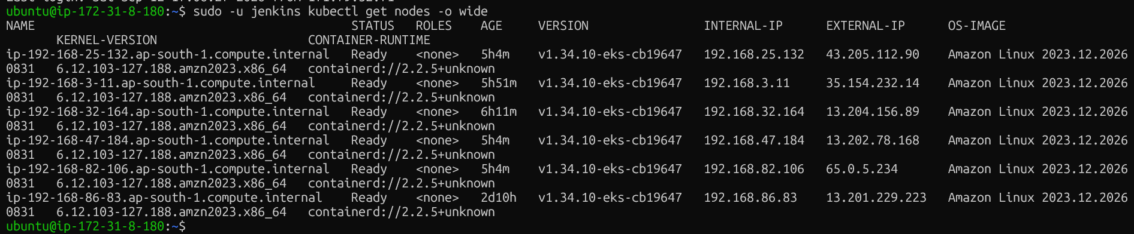

Kubernetes Application Deployment

Kubernetes Pod Verification
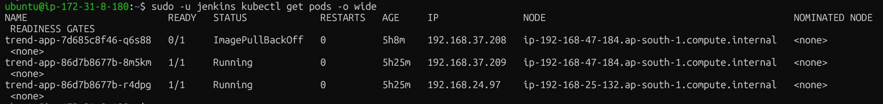

Kubernetes LoadBalancer





Jenkins CI/CD Pipeline + Webhook
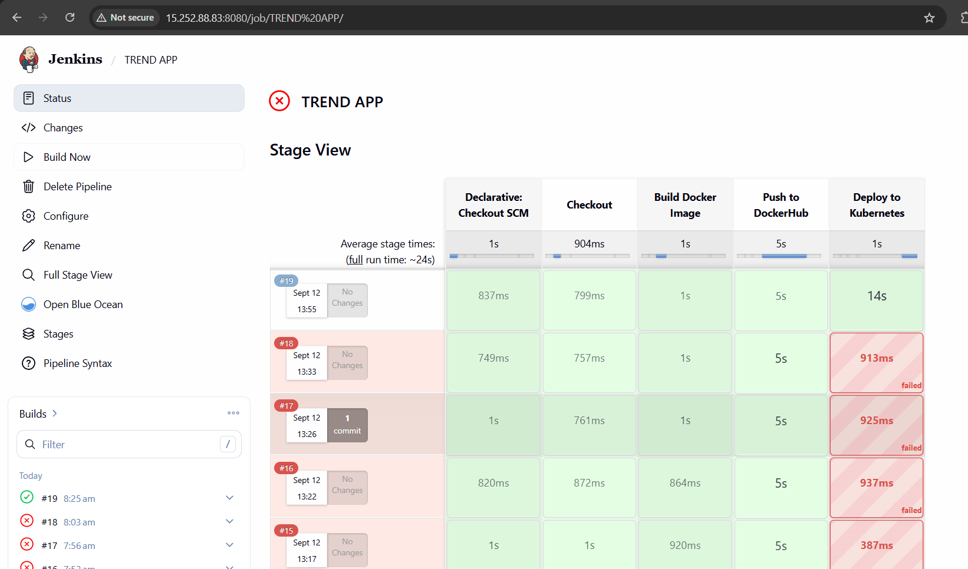

Started by user unknown or anonymous
Obtained Jenkinsfile from git https://github.com/NaveenOVN/Trend.git
[Pipeline] Start of Pipeline
[Pipeline] node
Running on Jenkins in /var/lib/jenkins/workspace/TREND APP
[Pipeline] {
[Pipeline] stage
[Pipeline] { (Declarative: Checkout SCM)
[Pipeline] checkout
The recommended git tool is: git
using credential github-creds
> git rev-parse --resolve-git-dir /var/lib/jenkins/workspace/TREND APP/.git # timeout=10
Fetching changes from the remote Git repository
> git config remote.origin.url https://github.com/NaveenOVN/Trend.git # timeout=10
Fetching upstream changes from https://github.com/NaveenOVN/Trend.git
> git --version # timeout=10
> git --version # 'git version 2.34.1'
using GIT_ASKPASS to set credentials TREND APP
> git fetch --tags --force --progress -- https://github.com/NaveenOVN/Trend.git +refs/heads/*:refs/remotes/origin/* # timeout=10
> git rev-parse refs/remotes/origin/main^{commit} # timeout=10
Checking out Revision dc603117fc0c83a64ea923ddd8d2fa4ed889ea73 (refs/remotes/origin/main)
> git config core.sparsecheckout # timeout=10
> git checkout -f dc603117fc0c83a64ea923ddd8d2fa4ed889ea73 # timeout=10
Commit message: "Fix deploy stage with --validate=false"
> git rev-list --no-walk dc603117fc0c83a64ea923ddd8d2fa4ed889ea73 # timeout=10
[Pipeline] }
[Pipeline] // stage
[Pipeline] withEnv
[Pipeline] {
[Pipeline] withCredentials
Masking supported pattern matches of $DOCKERHUB_CREDENTIALS or $DOCKERHUB_CREDENTIALS_PSW or $GITHUB_CREDENTIALS or $GITHUB_CREDENTIALS_PSW
[Pipeline] {
[Pipeline] withEnv
[Pipeline] {
[Pipeline] stage
[Pipeline] { (Checkout)
[Pipeline] git
The recommended git tool is: git
using credential github-creds
> git rev-parse --resolve-git-dir /var/lib/jenkins/workspace/TREND APP/.git # timeout=10
Fetching changes from the remote Git repository
> git config remote.origin.url https://github.com/NaveenOVN/Trend.git # timeout=10
Fetching upstream changes from https://github.com/NaveenOVN/Trend.git
> git --version # timeout=10
> git --version # 'git version 2.34.1'
using GIT_ASKPASS to set credentials TREND APP
> git fetch --tags --force --progress -- https://github.com/NaveenOVN/Trend.git +refs/heads/*:refs/remotes/origin/* # timeout=10
> git rev-parse refs/remotes/origin/main^{commit} # timeout=10
Checking out Revision dc603117fc0c83a64ea923ddd8d2fa4ed889ea73 (refs/remotes/origin/main)
> git config core.sparsecheckout # timeout=10
> git checkout -f dc603117fc0c83a64ea923ddd8d2fa4ed889ea73 # timeout=10
> git branch -a -v --no-abbrev # timeout=10
> git branch -D main # timeout=10
> git checkout -b main dc603117fc0c83a64ea923ddd8d2fa4ed889ea73 # timeout=10
Commit message: "Fix deploy stage with --validate=false"
[Pipeline] }
[Pipeline] // stage
[Pipeline] stage
[Pipeline] { (Build Docker Image)
[Pipeline] sh
+ docker build -t nawin28/trend-app:19 .
DEPRECATED: The legacy builder is deprecated and will be removed in a future release.
Install the buildx component to build images with BuildKit:
https://docs.docker.com/go/buildx/

Sending build context to Docker daemon 18.51MB

Step 1/5 : FROM nginx:alpine
---> 72ba65eb42c1
Step 2/5 : WORKDIR /usr/share/nginx/html
---> Using cache
---> c9d2f999e7ba
Step 3/5 : COPY dist/ .
---> Using cache
---> 83aacdb4942d
Step 4/5 : EXPOSE 80
---> Using cache
---> 86e775a1eaa1
Step 5/5 : CMD ["nginx", "-g", "daemon off;"]
---> Using cache
---> 417f4d70c125
Successfully built 417f4d70c125
Successfully tagged nawin28/trend-app:19
[Pipeline] }
[Pipeline] // stage
[Pipeline] stage
[Pipeline] { (Push to DockerHub)
[Pipeline] sh
+ echo ****
+ docker login -u nawin28 --password-stdin
Login Succeeded
[Pipeline] sh
+ docker push nawin28/trend-app:19
The push refers to repository [docker.io/nawin28/trend-app]
af7dd138f459: Waiting
58c524ea09ce: Waiting
51900e10fb9c: Waiting
6636b9fc203c: Waiting
5290ee46d5a1: Waiting
55afa1ecc21d: Waiting
850bf2dcecff: Waiting
bc98d7675616: Waiting
8f924cf5086c: Waiting
af7dd138f459: Waiting
58c524ea09ce: Waiting
51900e10fb9c: Waiting
6636b9fc203c: Waiting
5290ee46d5a1: Waiting
55afa1ecc21d: Waiting
850bf2dcecff: Waiting
bc98d7675616: Waiting
8f924cf5086c: Waiting
58c524ea09ce: Waiting
51900e10fb9c: Waiting
6636b9fc203c: Waiting
5290ee46d5a1: Waiting
55afa1ecc21d: Waiting
850bf2dcecff: Waiting
bc98d7675616: Waiting
8f924cf5086c: Waiting
af7dd138f459: Waiting
51900e10fb9c: Waiting
6636b9fc203c: Waiting
5290ee46d5a1: Waiting
55afa1ecc21d: Waiting
850bf2dcecff: Waiting
bc98d7675616: Waiting
8f924cf5086c: Waiting
af7dd138f459: Waiting
58c524ea09ce: Waiting
6636b9fc203c: Waiting
5290ee46d5a1: Waiting
55afa1ecc21d: Waiting
850bf2dcecff: Waiting
bc98d7675616: Waiting
8f924cf5086c: Waiting
af7dd138f459: Waiting
58c524ea09ce: Waiting
51900e10fb9c: Waiting
5290ee46d5a1: Waiting
55afa1ecc21d: Waiting
850bf2dcecff: Waiting
bc98d7675616: Waiting
8f924cf5086c: Waiting
af7dd138f459: Waiting
58c524ea09ce: Waiting
51900e10fb9c: Waiting
6636b9fc203c: Waiting
af7dd138f459: Waiting
58c524ea09ce: Waiting
51900e10fb9c: Waiting
6636b9fc203c: Waiting
5290ee46d5a1: Waiting
55afa1ecc21d: Waiting
850bf2dcecff: Waiting
bc98d7675616: Waiting
8f924cf5086c: Waiting
5290ee46d5a1: Waiting
55afa1ecc21d: Waiting
850bf2dcecff: Waiting
bc98d7675616: Waiting
8f924cf5086c: Waiting
af7dd138f459: Waiting
58c524ea09ce: Waiting
51900e10fb9c: Waiting
6636b9fc203c: Waiting
850bf2dcecff: Waiting
bc98d7675616: Waiting
8f924cf5086c: Waiting
af7dd138f459: Waiting
58c524ea09ce: Waiting
51900e10fb9c: Waiting
6636b9fc203c: Waiting
5290ee46d5a1: Waiting
55afa1ecc21d: Waiting
af7dd138f459: Waiting
58c524ea09ce: Waiting
51900e10fb9c: Waiting
6636b9fc203c: Waiting
5290ee46d5a1: Waiting
55afa1ecc21d: Waiting
850bf2dcecff: Waiting
bc98d7675616: Waiting
8f924cf5086c: Waiting
58c524ea09ce: Waiting
51900e10fb9c: Waiting
6636b9fc203c: Waiting
5290ee46d5a1: Waiting
55afa1ecc21d: Layer already exists
850bf2dcecff: Layer already exists
bc98d7675616: Waiting
8f924cf5086c: Waiting
af7dd138f459: Waiting
5290ee46d5a1: Waiting
bc98d7675616: Waiting
8f924cf5086c: Waiting
af7dd138f459: Waiting
58c524ea09ce: Waiting
51900e10fb9c: Waiting
6636b9fc203c: Waiting
6636b9fc203c: Waiting
5290ee46d5a1: Waiting
bc98d7675616: Waiting
8f924cf5086c: Waiting
af7dd138f459: Layer already exists
58c524ea09ce: Layer already exists
51900e10fb9c: Waiting
51900e10fb9c: Waiting
6636b9fc203c: Waiting
5290ee46d5a1: Waiting
bc98d7675616: Waiting
8f924cf5086c: Waiting
51900e10fb9c: Layer already exists
6636b9fc203c: Layer already exists
5290ee46d5a1: Layer already exists
bc98d7675616: Layer already exists
8f924cf5086c: Layer already exists
19: digest: sha256:417f4d70c125b28044ee902c75cfce8b0992652ef504abefc7191b3594333873 size: 2265
[Pipeline] }
[Pipeline] // stage
[Pipeline] stage
[Pipeline] { (Deploy to Kubernetes)
[Pipeline] sh
+ kubectl apply -f k8s/deployment.yaml --validate=false
deployment.apps/trend-app configured
+ kubectl apply -f k8s/service.yaml --validate=false
service/trend-app-service unchanged
+ kubectl rollout restart deployment trend-app
deployment.apps/trend-app restarted
+ kubectl get pods
NAME READY STATUS RESTARTS AGE
trend-app-7d685c8f46-sk9l6 0/1 Pending 0 3s
trend-app-86d7b8677b-p5cbg 1/1 Running 0 2d1h
trend-app-86d7b8677b-vtsj2 1/1 Running 0 2d1h
[Pipeline] }
[Pipeline] // stage
[Pipeline] }
[Pipeline] // withEnv
[Pipeline] }
[Pipeline] // withCredentials
[Pipeline] }
[Pipeline] // withEnv
[Pipeline] }
[Pipeline] // node
[Pipeline] End of Pipeline
Finished: SUCCESS

Monitoring
